COVERING SHEET – INSTRUCTIONS

THIS COVERING SHEET MUST BE REMOVED BEFORE SENDING EASY READ QUESTIONNAIRE TO PATIENT.

The availability of the Easy Read questionnaire will be signposted on the mailing letters and administered at the request of the patient.
Once requested, the following steps should be taken.
Administering the request:
- Any highlighted yellow text on this Easy Read booklet should be personalised. The booklet contains both the Easy Read cover letter and questionnaire.
- The booklet should be posted to the patient alongside a return envelope. You can either use the Freepost address you have set up or include a stamped addressed envelope to a different processing address.
- Please log any Easy Read requests in the fieldwork monitoring spreadsheet.
- We recommend that patients who request an Easy Read are logged as opt-out. This will ensure they do not receive any further mailings. If the patient then takes part in the survey, the code should be changed to complete. At the time of the patient requesting the Easy Read, if it’s likely they will receive a further mailing (e.g. due to mailing deadlines) it is worth making them aware this will happen, but that an Easy Read will also be sent to them.
Processing the return:
- Manually enter responses into the excel data entry sheet for that patient.

Survey number: | [INSERT HERE]

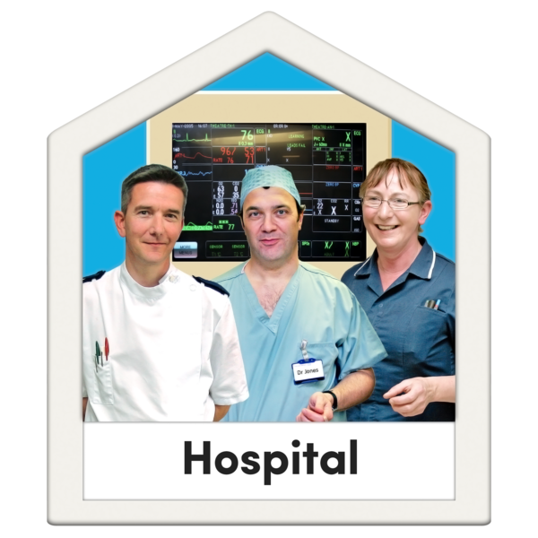
Please tell us about your last visit to the hospital
2020

Easy read version of the Inpatient Survey 2020

About this booklet
We would like you to answer some questions about your last visit to hospital.
Your answers will help hospitals improve their services for patients.
You can answer each question by putting a tick in the box next to the answer you want.
You can ask somebody to help you read the questions and answer them if you want.
But they should not tell you which answer to pick, because we want to know what you think.
You do not have to answer all the questions if you do not want to.
Your answers are private. We will not use your name when we share what we have found out from all the answers we receive.

 | Hospital food
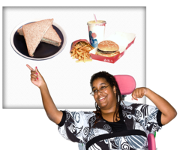 | - How good was the food you were given by the hospital?
 | ☐ Very good
 | ☐ Good
 | ☐ OK
 | ☐ Bad
 | ☐ Very bad
 | ☐ I was fed through a tube
 | ☐ I did not have any hospital food
 | ☐ I do not know or cannot remember
 | Doctors and nurses
 | - How good were the doctors and nurses at answering your questions in a way that you could understand?
 | ☐ Very good
 | ☐ Good
 | ☐ OK
 | ☐ Bad
 | ☐ Very bad
 | ☐ I did not have any questions
 | ☐ I do not know or cannot remember
 | - How good were the doctors and nurses at making you feel confident that you were being given the right treatment?
 | ☐ Very good
 | ☐ Good
 | ☐ OK
 | ☐ Bad
 | ☐ Very bad
 | ☐ I do not know or cannot remember

 | Your care and treatment
 | - How good were the doctors and nurses at helping you to take part in decisions about your care and treatment?
 | ☐ Very good
 | ☐ Good
 | ☐ OK
 | ☐ Bad
 | ☐ Very bad
 | ☐ I was not able to take part
 | ☐ I did not want to take part
 | ☐ I do not know or cannot remember
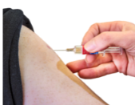 | - How good were the doctors and nurses at making you feel you could talk to them about your worries and fears?
 | ☐ Very good
 | ☐ Good
 | ☐ OK
 | ☐ Bad
 | ☐ Very bad
 | ☐ I do not know or cannot remember
 | - Think about when you were examined or treated in hospital. How good were the doctors and nurses at giving you enough privacy?
 | ☐ Very good
 | ☐ Good
 | ☐ OK
 | ☐ Bad
 | ☐ Very bad
 | ☐ I did not want this
 | ☐ I do not know or cannot remember
 | - Think about when you needed help from the doctors or nurses. How good were they at helping you when you needed it?
 | ☐ Very good
 | ☐ Good
 | ☐ OK
 | ☐ Bad
 | ☐ Very bad
 | ☐ I did not need help
 | ☐ I do not know or cannot remember
 | Leaving the hospital
 | - Think about before you left the hospital. How good were the doctors and nurses at telling you what would happen next with your care?
 | ☐ Very good
 | ☐ Good
 | ☐ OK
 | ☐ Bad
 | ☐ Very bad
 | ☐ I do not know or cannot remember
 | - Think about after you left hospital. How good were health or social care services at helping you with your health condition?
 | ☐ Very good
 | ☐ Good
 | ☐ OK
 | ☐ Bad
 | ☐ Very bad
 | ☐ I do not know or cannot remember
 | General questions
 | - In general, how good were the doctors and nurses at treating you with respect?
 | ☐ Very good
 | ☐ Good
 | ☐ OK
 | ☐ Bad
 | ☐ Very bad
 | ☐ I do not know or cannot remember
 | - In general, how good was your experience in hospital?
 | ☐ Very good
 | ☐ Good
 | ☐ OK
 | ☐ Bad
 | ☐ Very bad
 | ☐ I do not know or cannot remember
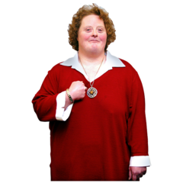 | About you
 | - How would you describe yourself?
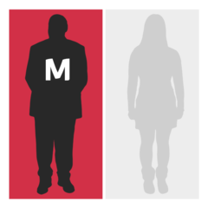 | ☐ Male
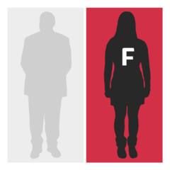 | ☐ Female
 | ☐ I do not want to say
 | ☐ Other (please write down how you would describe yourself below)
 | - How old are you? Please write your age in years below.
 | Anything else
- Is there anything else you would like to tell us about your experience in hospital? Please write it below.

We will take out any information that could identify you before making your answer public. But the hospital and the people (like CQC) you send these answers to will see your full answer. If your answer needs looking into, we may share it with the best person to help.

 | Thank you very much for answering these questions.
 | When we have looked at all the answers from everyone, we will write a report about what we found and put it on our website at: www.cqc.org.uk/surveys.
 | What to do with your answers
 | Please post your answers back in the FREEPOST envelope provided. No stamp is needed.
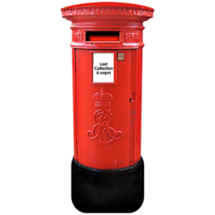 | If you do not have your FREEPOST envelope, please send your answers to <INSERT FREEPOST ADDRESS>

